

Foundations of Programming
Assignment No. : 12

PROBLEM STATEMENT:
Write a program in C to accept two numbers from the user and compute:
- The smallest common divisor of the two numbers (other than 1, if any)
- The Greatest Common Divisor (GCD) of the two numbers

OBJECTIVE:
• To understand the use of mathematical operations in C.
• To implement loops and conditional statements
. • To perform number-based computations.
• To enhance logical thinking using menu-driven programs.

THEORY:
Divisors and the Greatest Common Divisor (GCD) are fundamental concepts in number theory. The smallest common divisor of two numbers is the smallest positive integer greater than 1 that divides both numbers. The GCD of two numbers is the largest positive integer that divides both numbers without leaving a remainder. In C programming, these operations can be efficiently implemented using loops and the Euclidean algorithm, which repeatedly applies the modulo operation until the remainder becomes zero.

PLATFORM:
Linux

ALGORITHM:
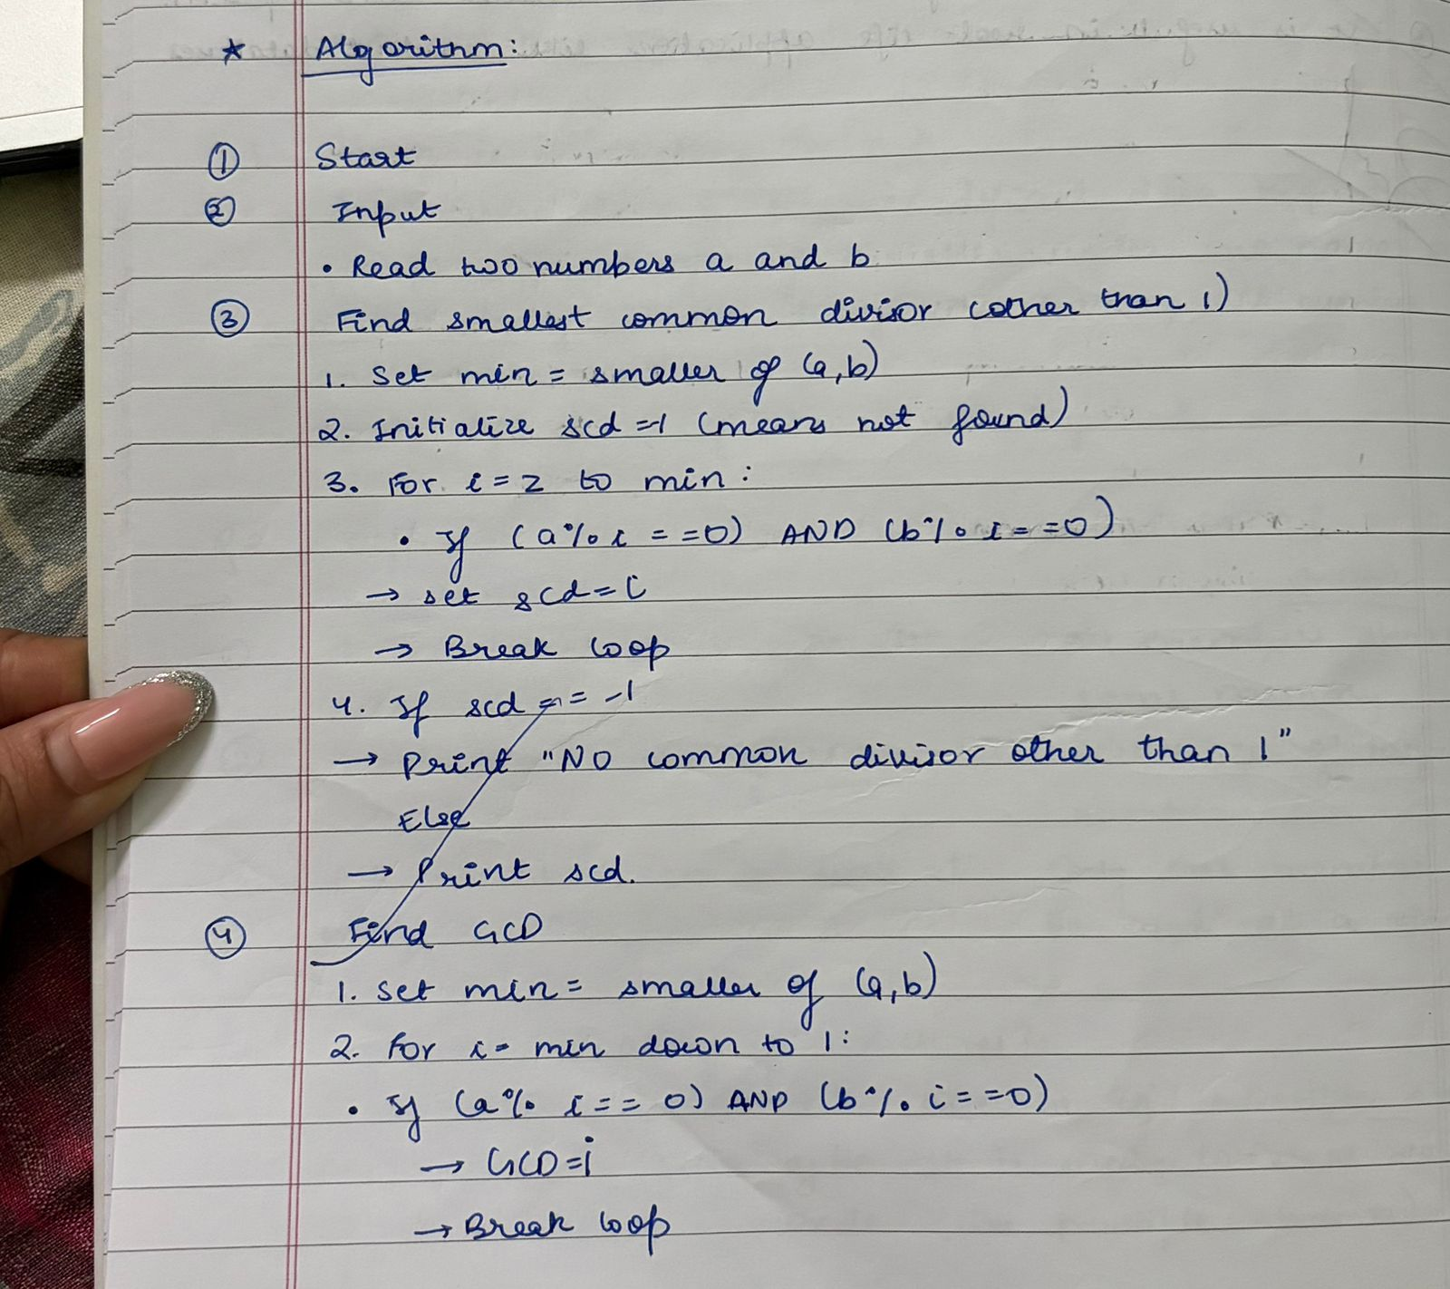
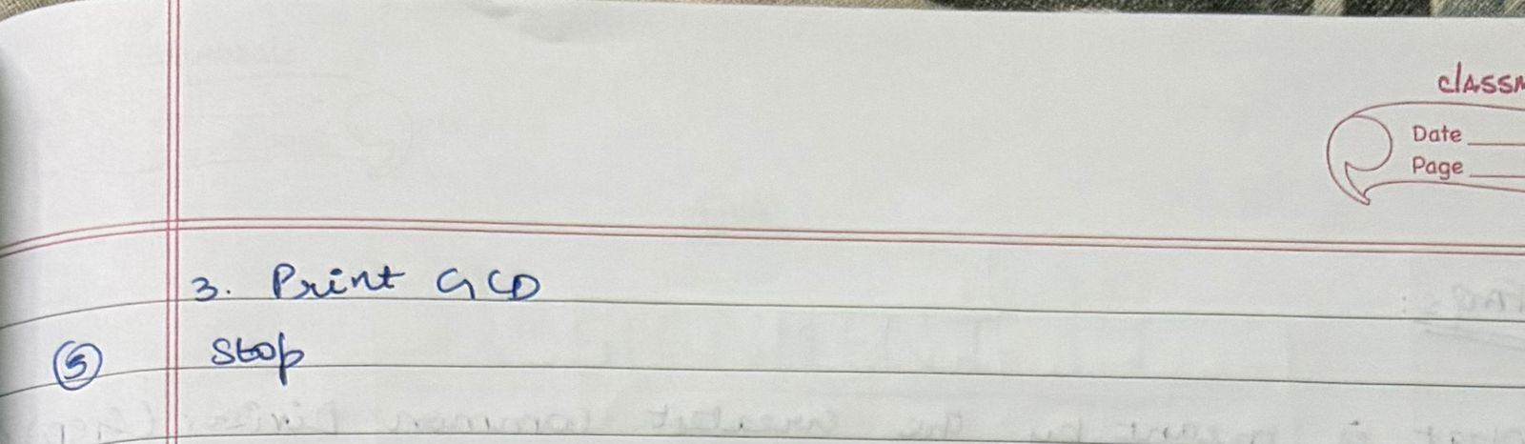

FLOWCHART:
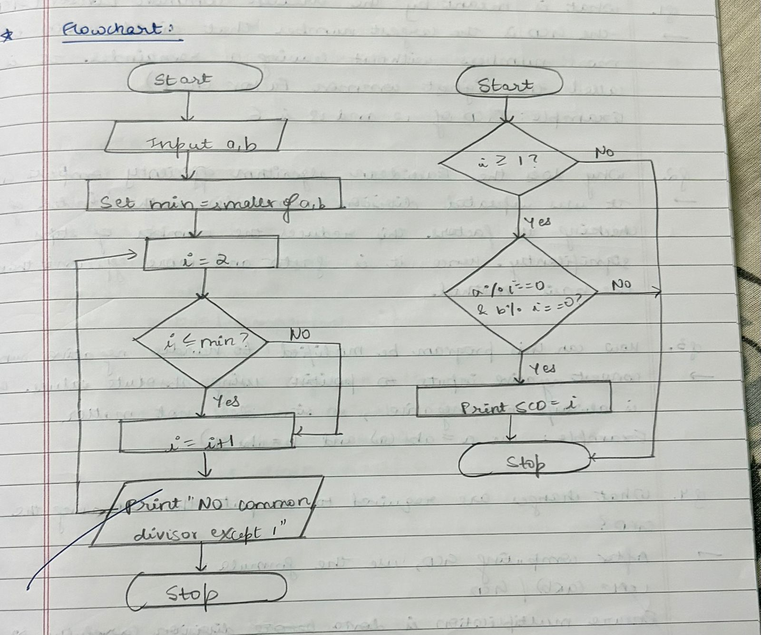

C PROGRAM:
#include <stdio.h>

int main() {
int a, b, i, gcd, smallest = -1;
// Input
printf("Enter two numbers: ");
scanf("%d %d", &a, &b);

// GCD using Euclidean Algorithm
int x = a, y = b;
while (y != 0) {
int temp = y;
y = x % y;
x = temp;
}
gcd = x;

// Smallest common divisor (other than 1)
for (i = 2; i <= (a < b ? a : b); i++) {
if (a % i == 0 && b % i == 0) {
smallest = i;
break;
}
}
// Output
if (smallest != -1)
printf("Smallest Common Divisor (other than 1): %d\n", smallest);
else
printf("No common divisor other than 1 (Co-prime numbers)\n");

printf("GCD = %d\n", gcd);

return 0;
}

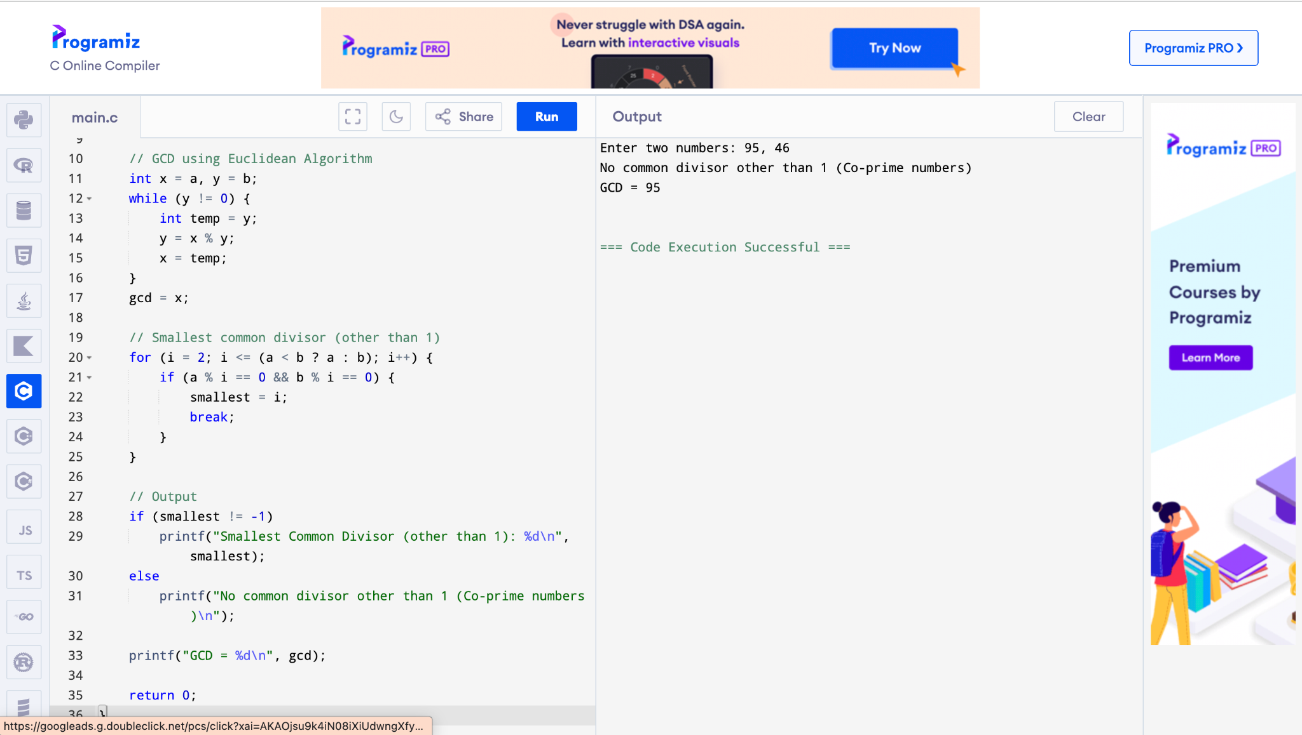

CONCLUSION:
Thus, the program to find the smallest common divisor and the Greatest Common Divisor of two numbers was successfully implemented using C programming. This program demonstrates the use of loops, conditional statements, and the Euclidean algorithm.

FAQs:
- What is meant by the Greatest Common Divisor (GCD)?
- Why does the Euclidean algorithm efficiently compute the GCD?
- How can this program be modified to handle negative numbers?
- What changes are required to compute the Least Common Multiple (LCM) using the GCD?
- How can this program be extended to find the LCM of two numbers?

